
Architecture Definition
Robotic Cognition System for Wheelchair
Unicamp

Author: Tarcisio Franco de Carvalho

Table of Contents
1 Purpose of this Document 3
2 Scope and Goals 4
3 Architecture Overview 5
4 Architecture Decisions 6

Document Information
Project Name: | Robotic Cognition System for Wheelchair
Prepared By: | Tarcisio Franco de Carvalho | Document Version No: | 1.0
Title: | Architecture Definition | Document Version Date: | 07/Oct/2020
Reviewed By: |  | Review Date:
Distribution List
From | Date | Phone/Fax/Email

Document Version History
Version  Number | Version  Date | Revised By | Description
1.0 | 07/Oct/2020 | Tarcisio Franco | Initial Version

Purpose of this Document

This document packages the architecture overview and decisions for the project Robotic Cognition System for Wheelchair.

Scope and Goals

This is an initiative of the UNICAMP Faculty of Electrical Engineering and Computation in Brazil to develop a research project to create a low cost wheelchair robot cognition system for person with physical disabilities.

Architecture goals in scope
- The components should be developed considering the re-usability for further researches
- The control of the cognition system should be developed in a way to have flexibility in choosing the user interface
- The environment can be simulated to avoid costs and speed up the research

Architecture goals out of scope
- User Interface adapted for person with disabilities as face recognition approach will be considered in further researches. For this current project a simple web user interface are in scope to simulate all the solution controls

Constraints and limitations
- The test in a real environment will depend of the availability of the robot wheelchair during the project life cycle.

Architecture Overview

Use case context
The main users of this solution would be persons with body disabilities that uses a robot wheelchair to move safely considering terrain unevenness.
The two solutions below will be considered as central input components for this project to produce the desired user target location classification as safe or unsafe considering the robot’s climb capabilities against the unevenness of the terrain:
- The Ph.D Eric Romer has developed the idea to have a diode laser in a wheelchair that can be pointed to a desired user target goal based on where the user is looking.
- The Ph.D Mauro Bellone has developed the UPD library that classifies the unevenness of a terrain using traversability analysis on point cloud data.

System Components Diagram
The system components have the following layers:
- Simulated Environment: Represents all components related to the user environment simulation as depth sense device, laser and the wheelchair itself.
- Back-end Environment: Represents all the logical components related to this solution, as to move the robot to the target point, classify the robot passage condition, convert laser range data to point cloud data, etc.
- Front-end Environment: Represents all the controls for this solution, defined in a REST API architecture. For testing purposes was developed a web user interface layer to present the controls functionalities.
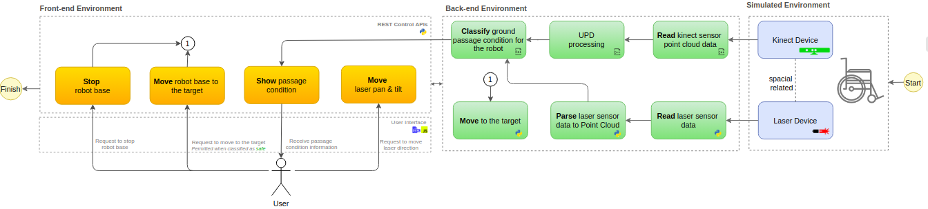

Architecture Decisions

The architecture decisions below were made as a principle for the development of this project:

Decision | Why
Use ROS (Robot Operational System) framework as platform for components of this system | - ROS has many built-in components that can be reused as robot navigation stack, point cloud data conversions and messages, etc.  - The custom components developed for this project can be encapsulated as ROS node and take the advantages of the integration with other ROS built-in nodes.
Component oriented development as a service concept | - To speed up and help further research projects, the components developed for this project should be designed as a service to be reused in order projects. Also, these components should have its own documentation regarding its setup and run.
Gazebo Software as Environment Simulation | - As the ROS was selected as main framework for this project, we decided to use Gazebo that has more built-in integration components with ROS. In case of using another software as V-REP, the solution should work as well with no much adjustments.
Python as main language | - The project will use C++ and Python. The priority is to use Python as it has less complexity the C++ for build and run, and it has more libraries for modern API architectures as REST APIs.
REST API architecture for interface controls | - Looking forward to help other researches in the user interface field for persons with disabilities, all the control of this solution should be developed in REST APIs, then modern user interfaces as mobile applications can take the advantage of this architecture.
UPD library for unevenness terrain classification | - The Ph.D Mauro Bellone has developed a library that uses traversability analysis to classify the unevenness of a terrain that will be an input for wheelchair robot passage classification.
Path planning | - The robot wheelchair should move in a smooth way to the target ensuring the comfort of the user during the movement and avoiding instabilities.

